**Children’s Miracle Network Hospitals**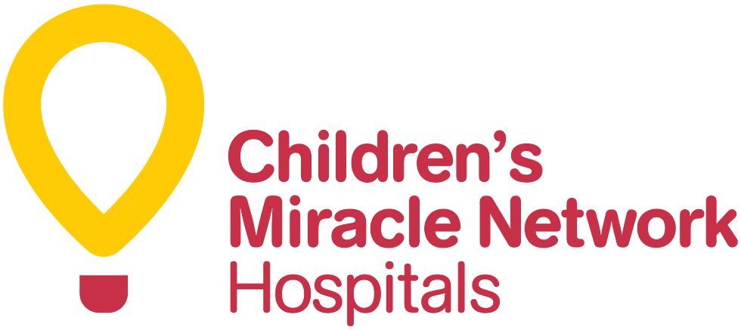

**ABOUT US**

Did you know that 62 children enter a Children’s Miracle Network Hospital every minute? These hospitals provide 32 million treatments each year to kids across the U.S. and Canada, and there’s more than 10 million kids entering a CMN hospital in North America alone every year. In order to provide the best care possible for these kids, CMN hospitals rely on support from the community and donations, because medical funds can be so expensive for families. There are 170 CMN hospitals, 97 corporate sponsors, over 100 celebrity sponsors, and millions of individuals who can help Children’s Miracle Network Hospitals and its endeavors to help care for sick children. Donations to Children'sMiracleNetwork Hospitals can help these kids by funding medical care, research and education that saves and improves their lives, because every child deserves hope and healing.

**OUR MISSION & VALUES**

**The mission of Children’s Miracle Network Hospitals is to increase funds and awareness through donations and outreach for sick or injured children for all CMN hospitals across America and Canada. Every day, these hospitals treat 16,200 kids with trauma, 2,329 surgeries, 2,128 kids with cancer, 925 babies in NICU, and 935 kids with diabetes. Every second, one child enters a Children’s Miracle Network Hospital and together, we can help make miracles happen for them. CMNH values prioritizing the kids, working to keep their medical costs as low as possible, and being dignified in never exploiting the children. CMNH works to provide care for children and assistance to their families. The vision CMNH has is to continue providing helpful means to these childrens and families through informing the public and accepting donations, in order for miracles to keep happening for children.**

**OUR STORY**

Children’s Miracle Network Hospitals began with a telethon in 1983 that raised a total of $840,000 for the sick children. Mick Shannon, who was the executive director of the March of Dimes, conceived the idea of CMNH. With the help of Joseph G. Lake, John Schneider, and Marie Osmond, Children’s Miracle Network was born and a successful telethon program was run.

These four individuals agreed on creating a network of member children’s hospitals, as well as a network of television stations. CMNH was founded on the principles that 100% of the proceeds would stay local to benefit local hospitals and children, kids come first always, the goal of maintaining the lowest cost ratio possible, and finally, dignity and class; never exploiting sick or injured children.

Mick, Joe, John and Marie dedicated their lives to recruiting hospitals, TV stations, and sponsors, always putting the kids first! 37 years, 170 hospitals, telethons becoming media outlets and coverage, and **$7,000,000,000** later, these founders have made the world a better place for ill children and their families.

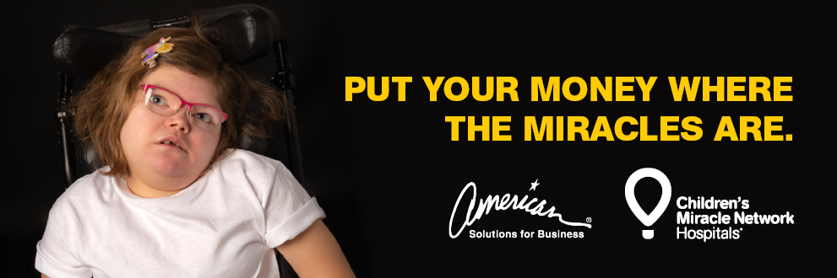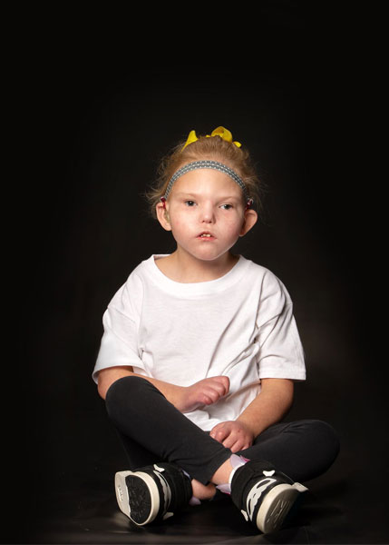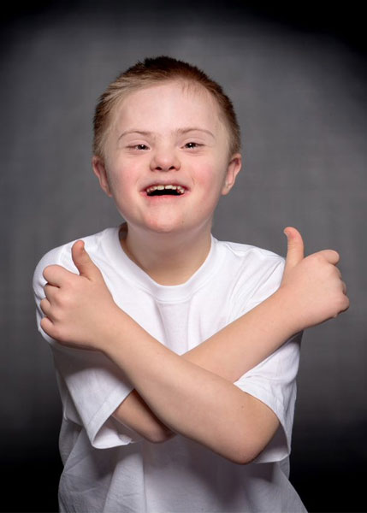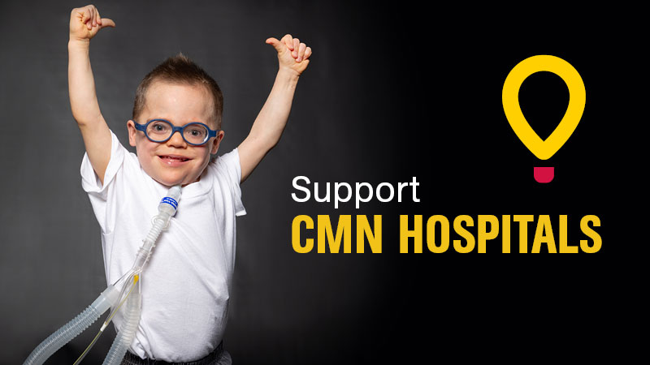



**WHO WE SERVE**

**CMNH works to provide whatever services are needed for sick or injured children across America and Canada in 170 different locations. The money raised goes directly into providing healthcare for the kids,** such as life-saving care, education and research. **Sixty-two children enter a Children's Miracle Network Hospital for treatment every minute. CMNH treats one in 10 children in North America each year. “Whether they suffer from common childhood afflictions like asthma and broken bones, or fight bigger challenges like birth defects or cancer, Children’s Miracle Network Hospitals provide comfort, treatment and hope to millions of sick kids.” (CMNH home page, 2021) CMNH helps to treat and cure many different kinds of sickness or injury that children may face. There is a CMNH available for any child or their family who may need assistance.**

**JOIN THE EFFORTS**

**There are millions of children who have needed, do need, or will need care from a Children’s Miracle Network Hospital. This organization has thrived on its support and donations from corporate and celebrity sponsors, as well as individuals across the world who want to see miracles happen for these children.**

**Visit our** [**How to Help**](https://childrensmiraclenetworkhospitals.org/how-to-help/#fundraiser) **page in order to learn ways to assist in CMNH efforts, it is possible to make a donation, start a fundraiser for the kids or simply learn how to spread the word. To contact CMNH headquarters via email, reach this address** [**support@cmnhospitals.org**](mailto:support@cmnhospitals.org)**. In order to reach HQ over telephone, contact** 801-214-7400. **For faxing purposes, you may contact** 801-746-6688.

FIND US ON SOCIAL MEDIA





[**Facebook**](https://www.facebook.com/cmnhospitals/)[**Instagram**](https://www.instagram.com/cmnhospitals/)[**Twitter**](https://twitter.com/CMNHospitals)[**Youtube**](https://www.youtube.com/channel/UCEPj015XSgEXe7a9BggujWg) [**Indeed**](https://www.linkedin.com/company/cmnhospitals)

**SOURCES CITED**

CMNH home page. (n.d.). Retrieved February 14, 2021, from <https://chfrichmond.childrensmiraclenetworkhospitals.org>/

2020-21 children's Miracle Network HOSPITALS® HEROES. (2020-2021). Retrieved February 14, 2021, from <https://www.gundersenhealth.org/cmn-hospitals/heroes/>

Social Media Icons from Google Doc images